QtrShoe Delivery App — Driver Guide

This guide is for drivers using the QtrShoe Delivery app to pick up orders, deliver items, collect payments, and handle returns.

Table of contents
- Login
- Home (Overview)
- My Deliveries (Driver view)
- Delivery flow (end-to-end)
- Reschedule delivery (same day)
- Cancel during delivery
- Full rejection (customer rejects all items)
- Return pickup (returning items to store)
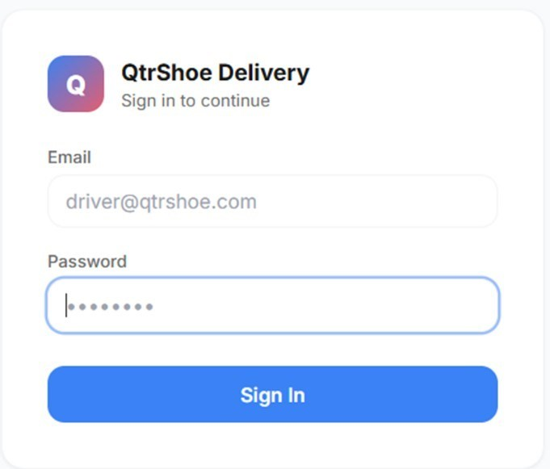
- Tips & troubleshooting Login
- Open QtrShoe Delivery.
- Enter your Email and Password.
- Tap Sign In.

• If you can’t sign in: double-check spelling, then contact your supervisor/ops team for access reset.

Home (Overview)
After logging in, the Home screen shows key metrics such as:

- Total Orders (for the current period)
- Delivery Rate
- Collected Revenue
- Average Delivery Time

You will also see order statuses such as:

- Pending: order exists but not started
- Assigned: assigned to you and ready to start
- In Transit: delivery started and you’re heading to the customer
- Delivered: completed successfully
- Failed: delivery could not be completed
- Returned: items were taken back to the store

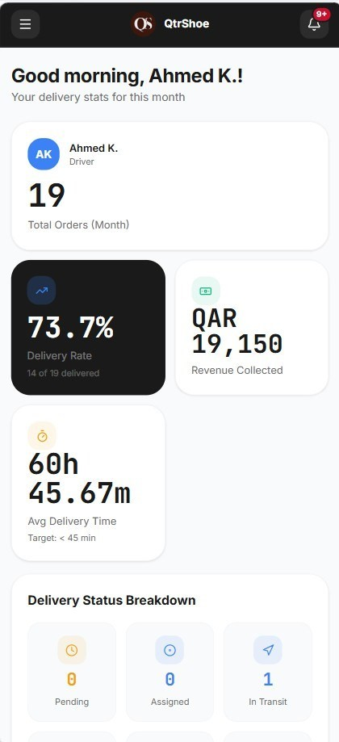

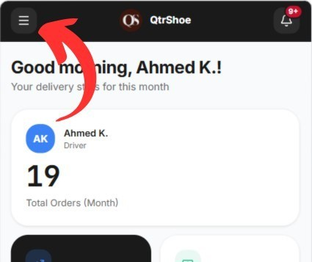
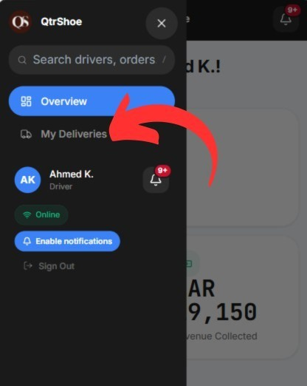
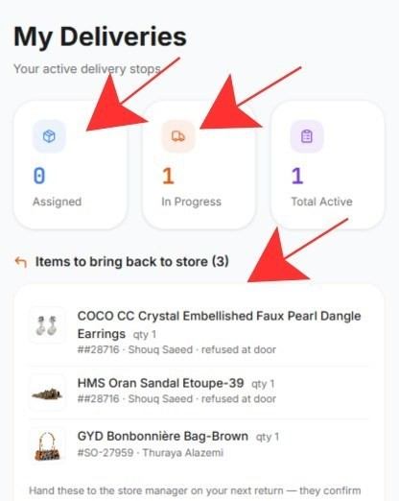
My Deliveries (Driver view)
This is your main working screen.
You can usually view:
- Your assigned orders
- Orders in progress
- Items to return to the store (if any) Each order typically shows:
- Customer name
- Location / address
- Phone number
- Amount
- Statu

Delivery flow (end-to-end)
Step 1 — Open the order

- Go to My Deliveries.
- Tap the order to open it.
- Review customer details (location + phone).

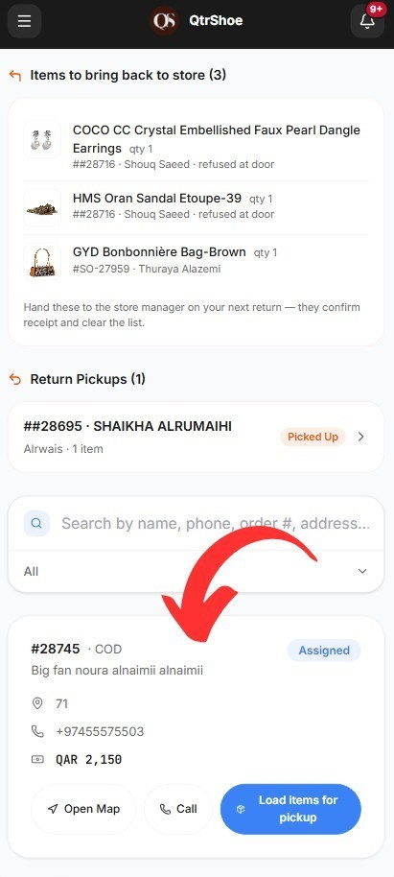

2 Load items (Pickup)
- Confirm the items you are picking up from the store.
- Select the items (often “Select all” if you have everything).
- Tap Confirm Pickup.

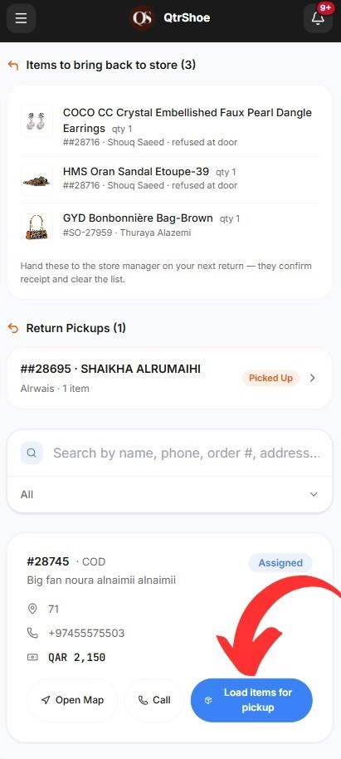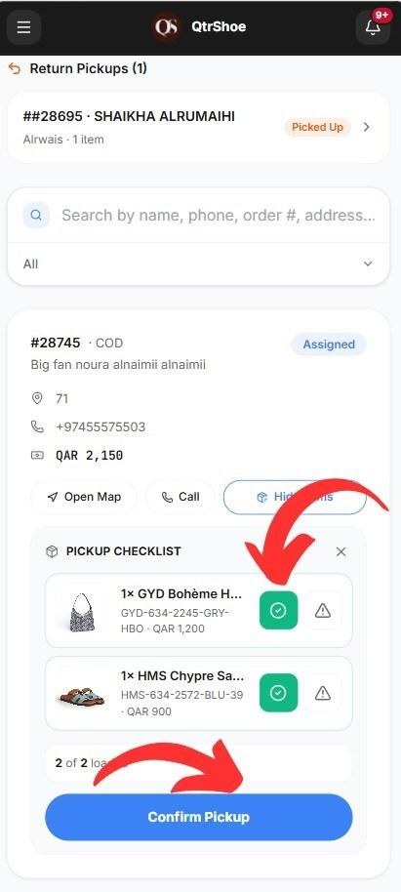
• If there is a problem with an item, tap the warning icon on the product and choose a reason:
- Out of Stock o Damaged o Wrong Item
- Other (write a note)

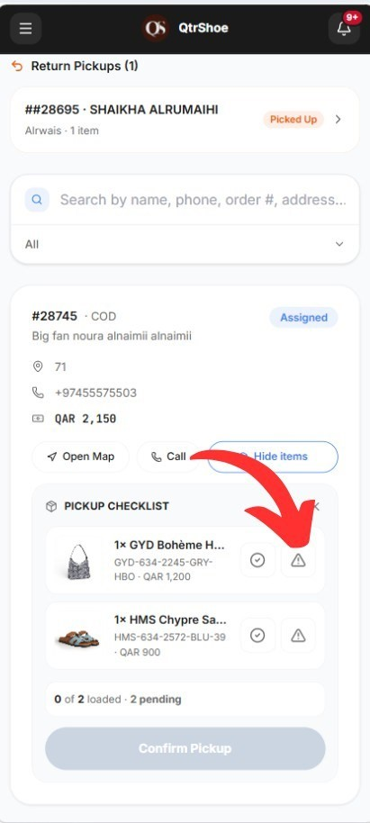
3 Start delivery
- Tap Start Delivery.
- Status changes to In Transit.
Navigation tip: use Open Map inside the order to navigate to the customer.

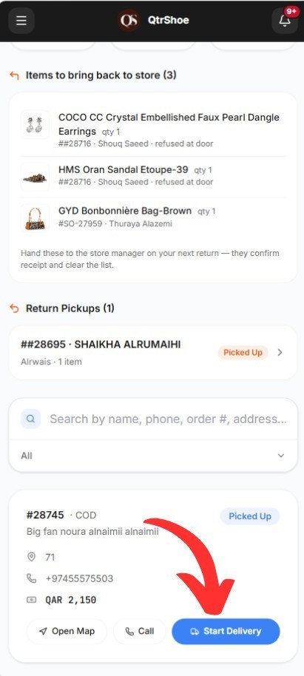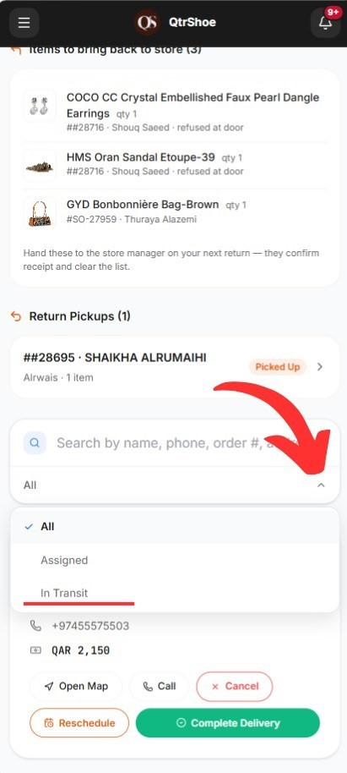
Change City
Use this option when the customer requests delivery to a different city.
This is used only after confirming the new delivery location with the customer.
Steps
- Click Change City
- Select the new city
- Review the delivery fee for that city
- Confirm the change

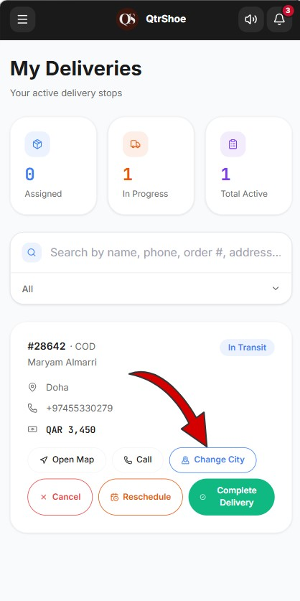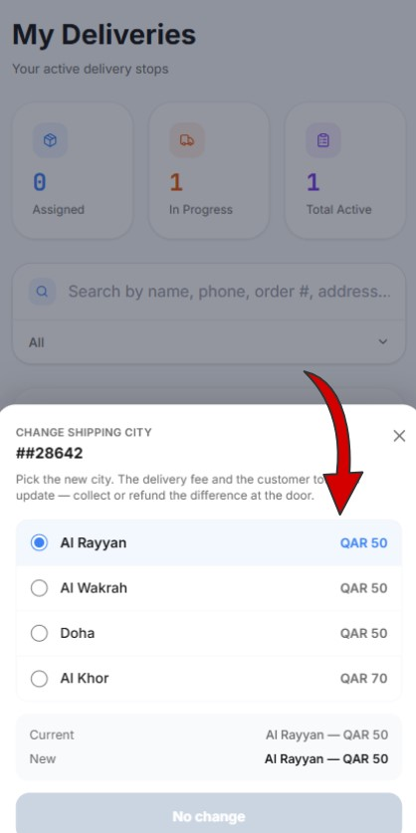

4 Complete delivery (at customer)
When you arrive:
- Tap Complete Delivery.
- Follow the completion steps in order:

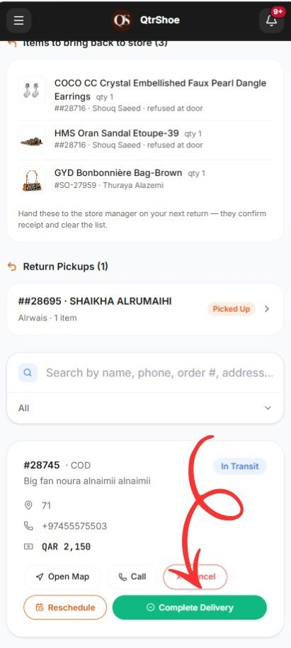
4.1 Proof Photo
- Take a photo (proof of delivery).
- Tap Next.

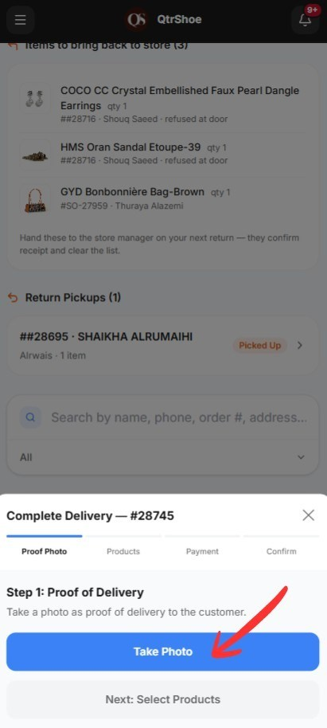

4.2 Products (Select delivered items)
- Select the items the customer actually received.
- You can:
o Deliver partial items (only some items delivered) o Adjust quantities o Remove unwanted items
Tap Next: Payment.
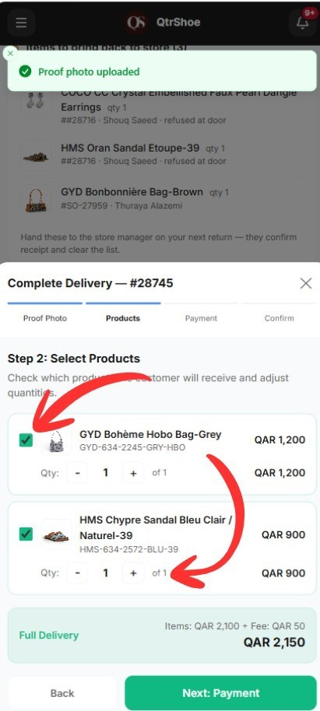

Exchange During Delivery
Sometimes, while delivering a new order, the customer may request an exchange for a past order.
In this case, follow the normal delivery steps. During product selection, click:
- Add an exchange against a past order
Then:
- Select the item being returned
- Confirm the replacement item
- Continue the remaining delivery steps as usual
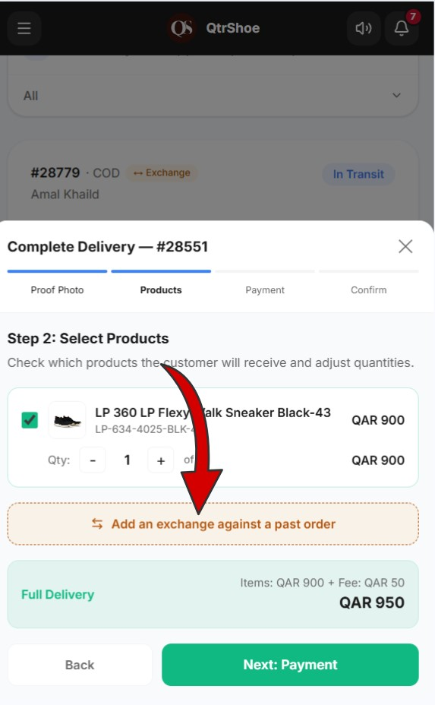
4.3 Payment
Choose payment type:
- Cash o Enter the amount collected.
- Bank Deposit o Enter the amount o Upload payment proof image.
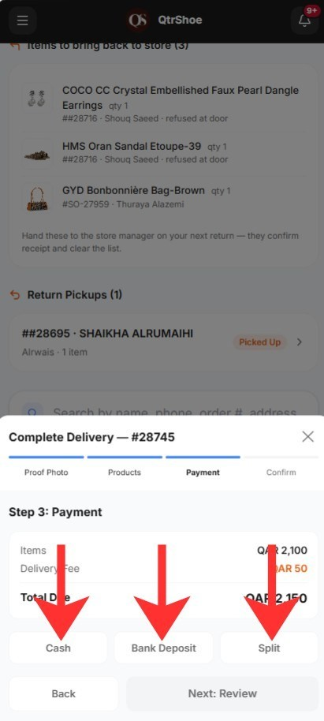
- Split Payment o Enter:
      - Cash amount
      - Bank amount
o Upload bank proof (if required)
Tap Next: Review.
4.3 Review
- Check all details carefully (items, totals, payment, variance).
4.4 Confirm
- Tap Confirm to finish.

⬛Important: After you confirm, you cannot edit the delivery.

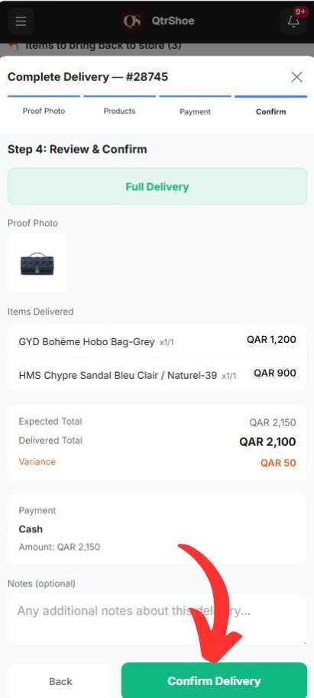

One Active Delivery at a Time

You cannot start a new delivery while another order is still active.
Before starting a new order, you must:
Complete the current delivery or reschedule the current order This helps ensure deliveries are handled one at a time.

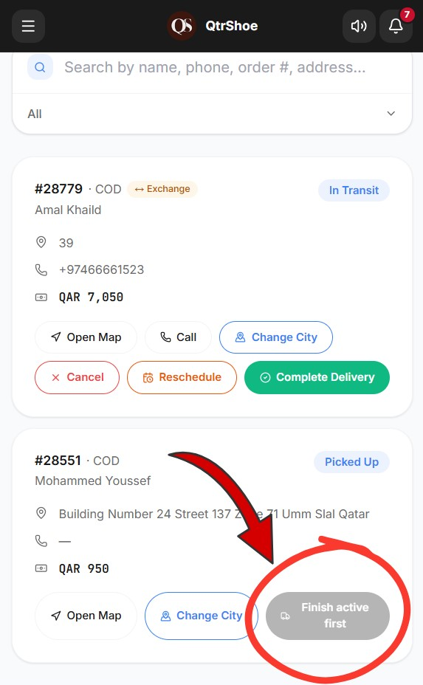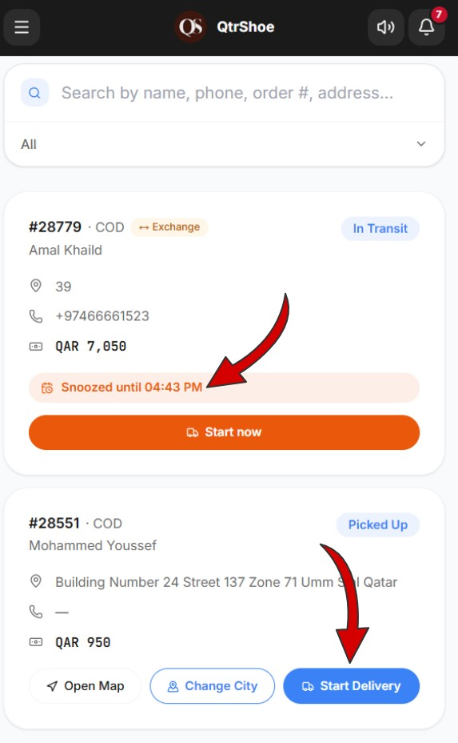

Reschedule delivery (same day)
You can reschedule an order within the same day only.
- Open the order from My Deliveries.
- Tap Reschedule.
- Pick a new time and confirm.

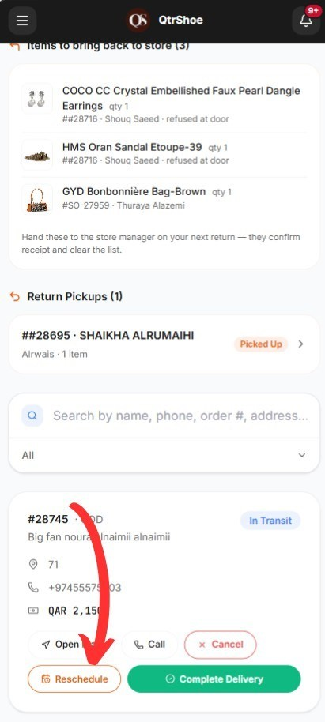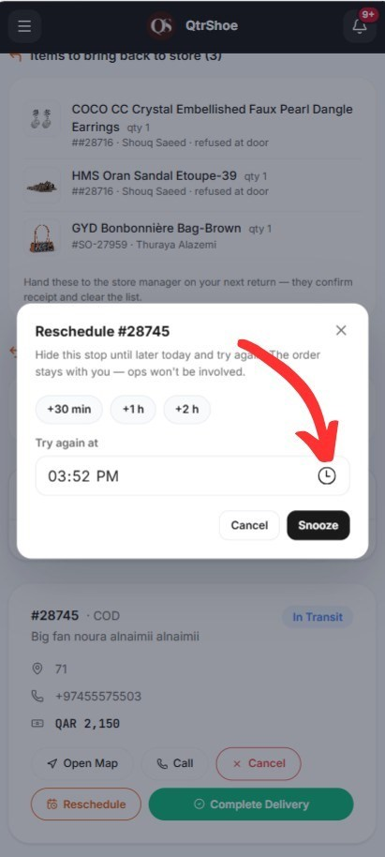

Cancel during delivery
After starting delivery, you can cancel if needed.
- Tap Cancel.
- Choose a cancellation reason:
- Wrong / undeliverable address
- Customer phone unreachable
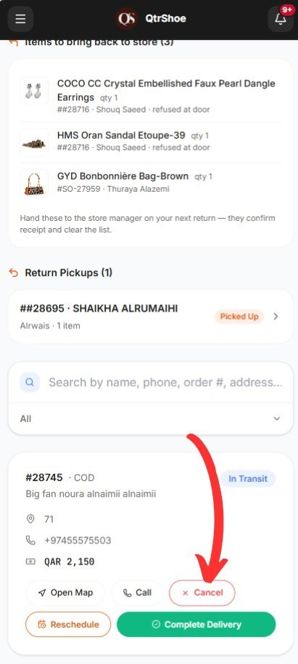
- Customer not at the location
- Customer refused delivery
- Couldn’t access building/area
- Driver/vehicle problem
- Other (add a note)
1. Submit cancellation.
The request is sent to the manager for review.
Full rejection (customer rejects all items)
If the customer rejects all items:
- In Step 2: Select Products, unselect all items.
- The button will change to Confirm Rejection.
- Tap Confirm Rejection.
- In Review, select the rejection reason.
- Tap Confirm Rejection.

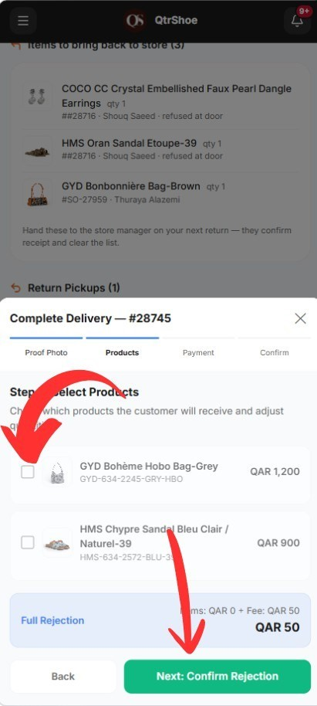

Return pickup (returning items to store)
Sometimes you will receive a Return Pickup task.
Step 1 — Open the return order 1. Go to the Return Pickup order.
2. Review:
- Customer details
- Location
- Items to collect

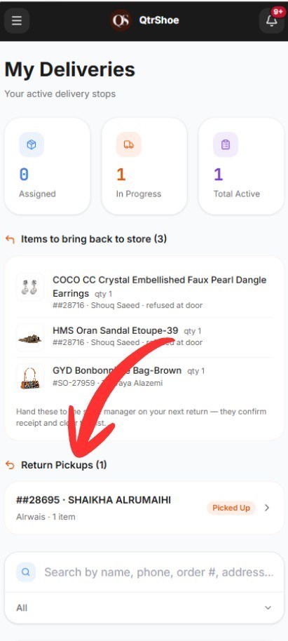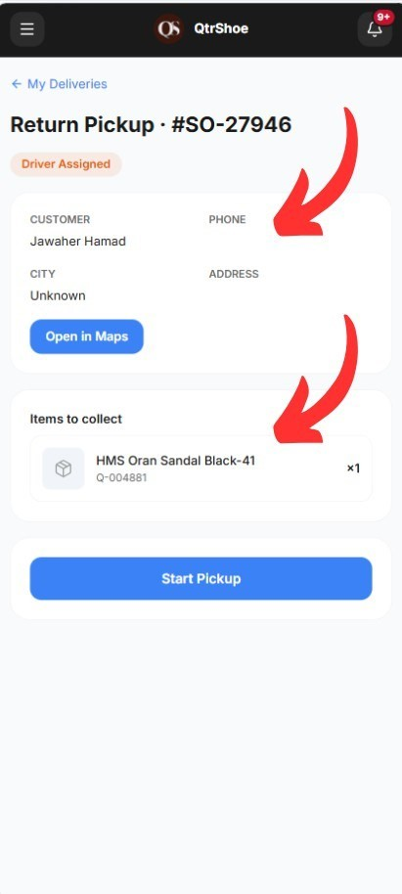
Step 2 — Confirm pickup
- Take a photo of the returned item(s).
- Optionally add notes (item condition: damaged, missing, etc.).
- Tap Mark as Picked Up.

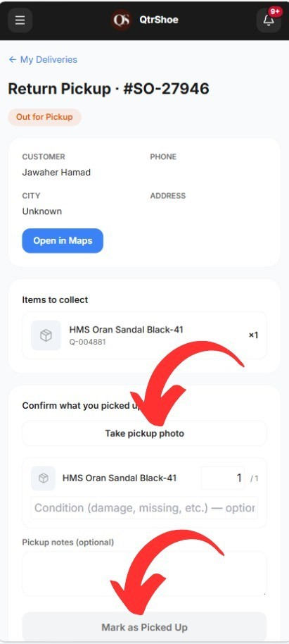
Step 3 — Deliver to store
After picking up the item(s):
1. Tap Delivery to Store to confirm you returned the item(s) to the store.

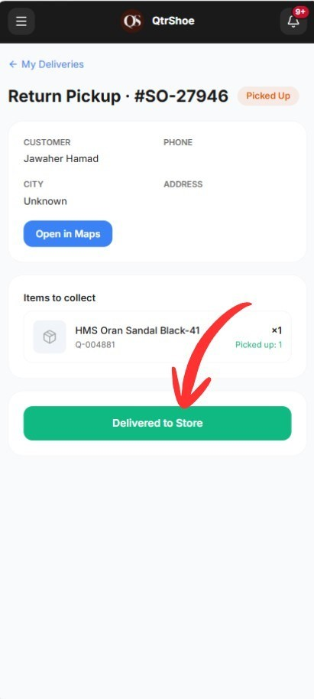

Exchange Order

You may receive an assigned exchange order.
This is a delivery task specifically for replacing a customer’s previous item.

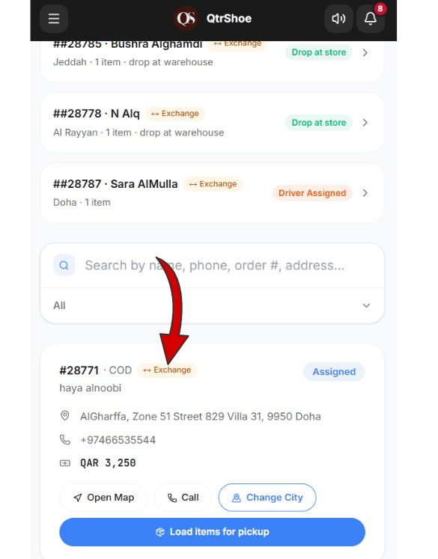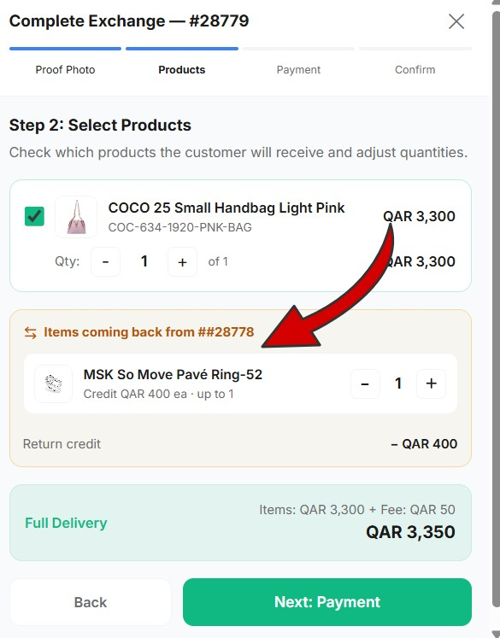

Notifications
The system sends real-time notifications to keep you updated.
- New Order Assigned
Sent when a new delivery order is assigned to you.
- Deposit Confirmed
Sent when accounting confirms your submitted deposit.
- Order Updates
Sent when there are updates related to:

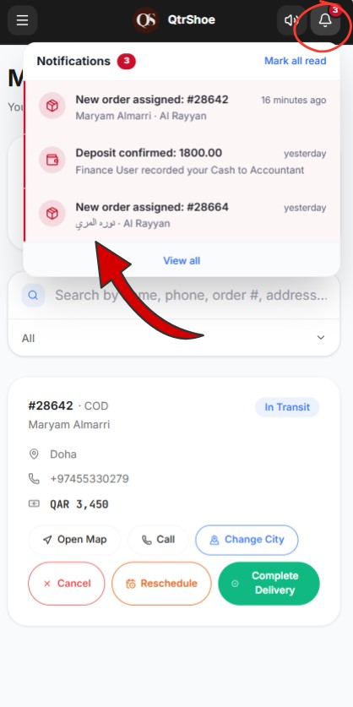

Tips & troubleshooting
- Always verify the selected items before confirming payment.
- Use clear, well-lit photos for proof and payment receipts.
- If something is missing/damaged, document it in notes before confirming.

